**Project Design Phase-II**

**Data Flow Diagram & User Stories**

|  |  |
| --- | --- |
| Date | 8 Oct 2025 |
| Team ID | SWUID20250179172 |
| Project Name | Social Media App |
| Maximum Marks | 4 Marks |

**Level 0 (Context-Level DFD)**

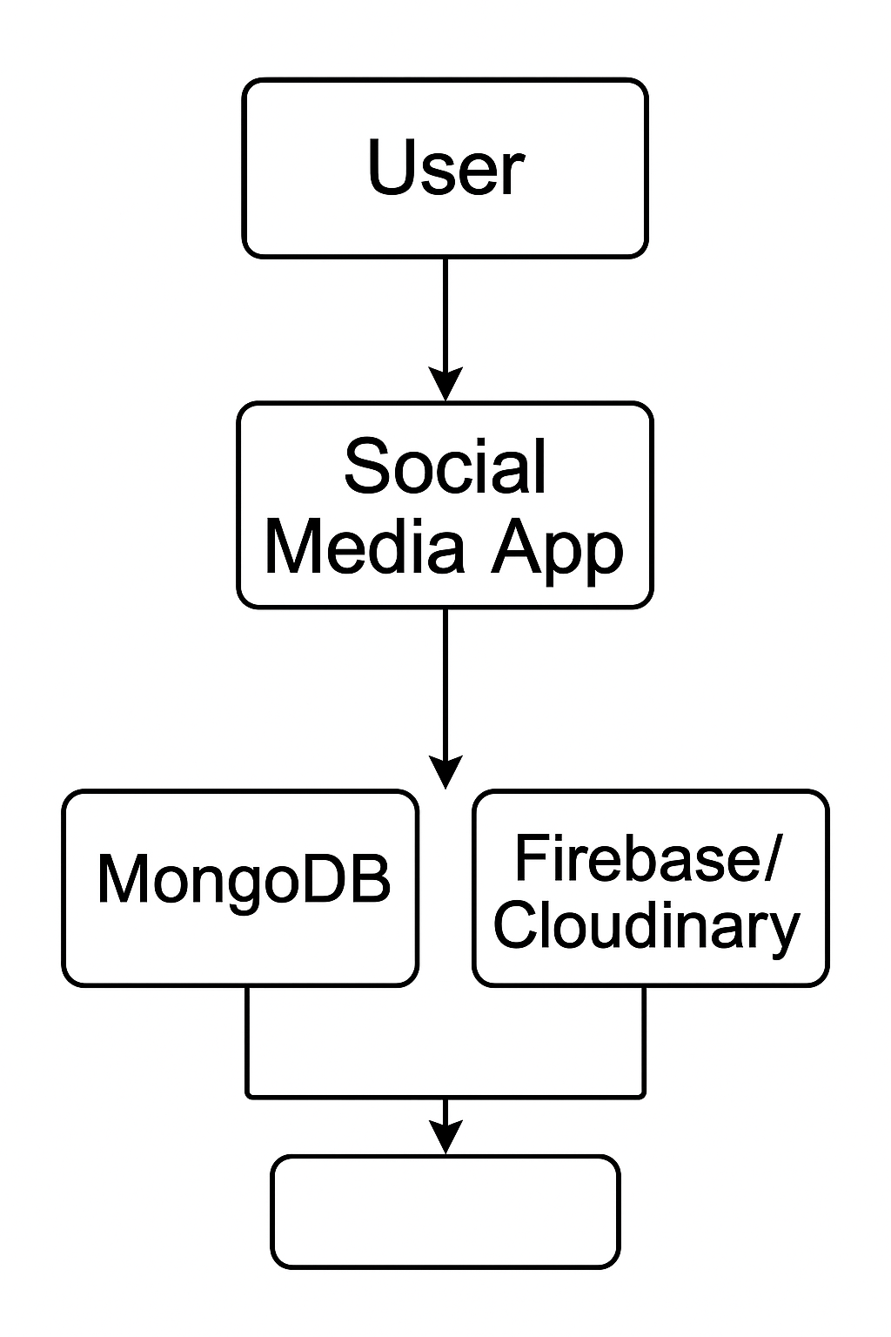

* User interacts with the app to perform actions like registration, posting, chatting.
* The Social Media App (built with MERN stack) serves as the central system.
* It interacts with:
  + MongoDB for storing user data, posts, comments, chats, etc.
  + Firebase/Cloudinary for media storage (images/videos).

**Level 1 DFD (Functional Breakdown)**

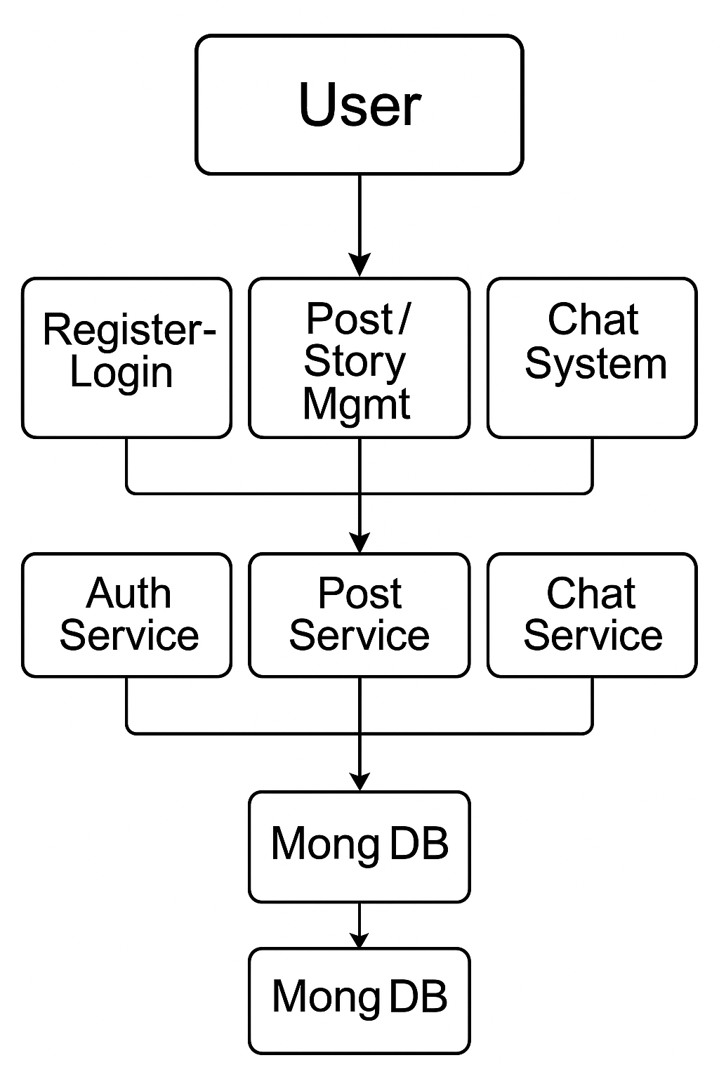

Each user action (e.g., login, chat, post) routes through dedicated services that interface with the database.

**User Stories**

| **User Story ID** | **As a user...** |
| --- | --- |
| US01 | I want to sign up and log in securely so that I can access my account safely. |
| US02 | I want to create and view posts so I can share content with my network. |
| US03 | I want to comment on and like posts so I can interact with other users. |
| US04 | I want to upload stories that expire in 24 hours so I can share updates easily. |
| US05 | I want to chat in real-time so I can communicate instantly with friends. |
| US06 | I want to follow/unfollow users so I can manage my social feed. |
| US07 | I want to receive real-time notifications so I don’t miss important activity. |
| US08 | I want to update my profile info and picture so I can personalize my account. |
| US09 | I want to save posts so I can view them later when needed. |
| US10 | I want a fast and responsive experience on mobile and desktop. |